GIVE WHEEL
﻿ https://help.givewheel.com/

A free fundraising platform where you can create a quick and easy personal fundraising page and send it to all your friends, family, work colleagues, ex work colleagues etc. The Give Wheel fundraiser creator takes you through the process step-by-step. On line donations are by far the easiest way to reach out to all your contacts and ask them to donate online. You can tag your link across social media, at the bottom of your emails – everywhere!

We’ve added a few useful quick links below and on their website you can type in any questions you have in their search bar. It is very easy to use and there are visual examples. Here’s a small extract showing what’s possible:

CUSTOMISABLE FEATURES on your fundraising page
Auto-Generated Posters | Produces downloadable promotional posters for fundraising pages with customisable designs.
Broadcast Message | Sends updates or announcements to all page supporters.
Custom Thank You Message | Allows fundraisers to personalise automated supporter thank you messages.
Offline Donations | Records donations made outside the platform and updates total raised.
QR Code Generation | Creates unique QR codes linking directly to fundraising pages.
Strava Integration | Displays Strava activity on fundraising pages for event date range.
Update Posts | Fundraisers can publish updates and share progress with supporters.

base FEATURES of your fundraising page
Apple & Google Pay Support | Accepts mobile donations through Apple Pay and Google Pay.
Bank Transfer Donations | Supports direct bank transfer payments for donations >£500.
Direct Charity Disbursement | Donations transferred to charities automatically, on a monthly basis.
Donor Messages | Allows donors to leave public messages with their contributions, displayed on the fundraising page.
Gift Aid Support | Enables Gift Aid collection for eligible UK donations
Guest Donations | Permits donations without requiring donor account registration.
Multi-Currency Donations | Accepts contributions in GBP, USD, EUR, AUD and CAD.
Page Shortlink | Generates a short, shareable link for each fundraising page.
Quick Share Links | Provides built-in links for sharing pages across social platforms and channels.

HOW DO I UPDATE MY FUNDRAISING PAGE

Sample Profile Page
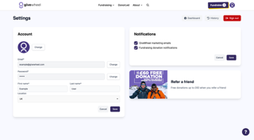
Once set up, you can update any details about your event at any time by selecting the Manage Page button from your fundraising page.
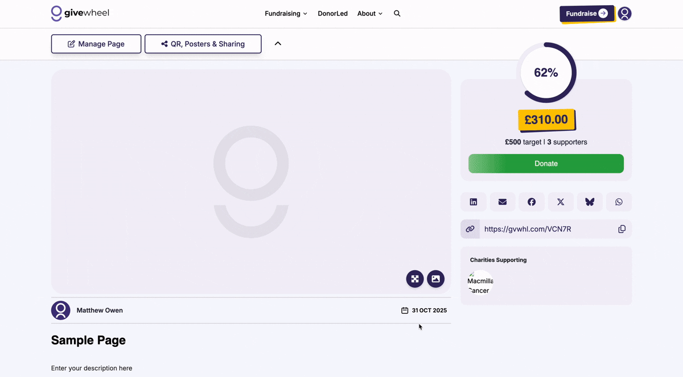How To: Edit your fundraising page
From this menu you can choose to:
- Add a custom thank you message
- Customise your page URL and page close date
- Customise a widget to add to your own website
- Integrate a Strava feed into your page
- Export data associated with your fundraiser
- Generate a QR code to link to your page
- Upload media as an update post
- Broadcast a message to your donors
To edit core details of your page, you'll need to select the 'Edit Page' button on this menu. From here you can amend your core details:
- Page title
- Event date
- Chosen charities and customisable split
- Page description
- Cover photo

HOW TO THANK MY SUPPORTERS

There are two options to thank your supporters on GiveWheel:
  - An automated message, delivered to donors with their donation confirmation email
  - One-off broadcasted messages delivered to donors via email

Automated Thank You Message
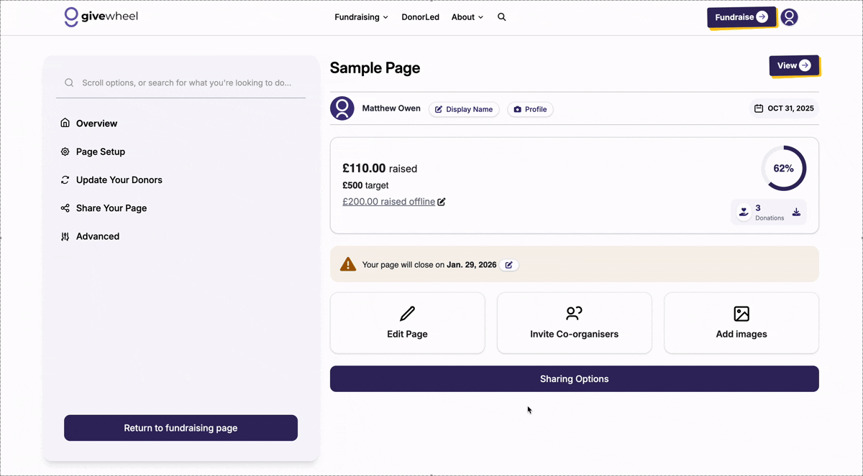How To: Add a thank you message
To add an automated thank you message, head to your page's Edit menu by selecting the edit icon on your fundraising page.
Then select 'Thank you message' from the left hand sidebar to enter and confirm your automated thank you message. This will be sent in all future donation confirmation emails.

Broadcast a Message to your supporters

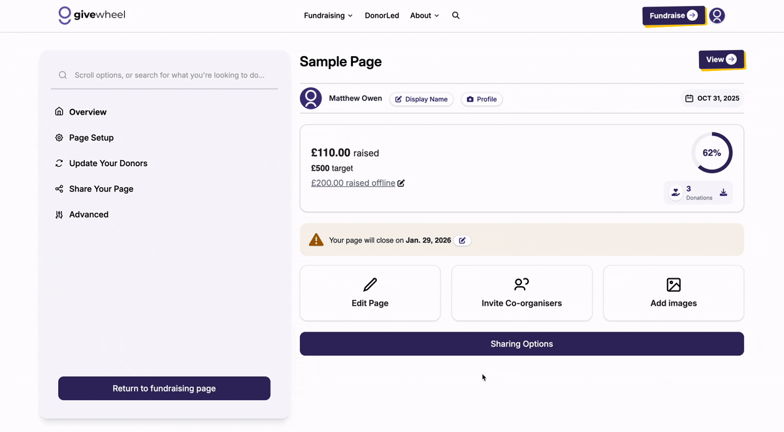How To: Broadcast a message
To broadcast a message to all donors, head to your page's Edit menu by selecting the edit icon on your fundraising page.
Select 'Message' in the left hand sidebar. You can then enter your message, opt whether to show your email for replies and submit your message.
Once submitted, your message will be delivered to all donors via email.

GIVE WHEEL – links to useful pages

A few links to the Give Wheel Site, for anything else you can search on their website – it’s easy!

How can I set up a fundraising page?  help.givewheel.com | 

Managing Your Page  help.givewheel.com | 

How do I manage my account?  help.givewheel.com | 

How can I generate a QR code for my fundraising page?  help.givewheel.com | 

When will my fundraising page close?
help.givewheel.com

How do I manage my contact preferences?  help.givewheel.com | 

How do I update my fundraising page or chosen charities?  help.givewheel.com | 

GiveWheel Full Service Directory
help.givewheel.com

