Heavy metal Truants Marketing

Set up a QR code!
There are many free ones available to use but some will require a login or password, but you shouldn’t need to pay for one – unless you want it to look fancy.
A quick and easy one is Adobe https://www.adobe.com/express/feature/image/qr-code-generator.

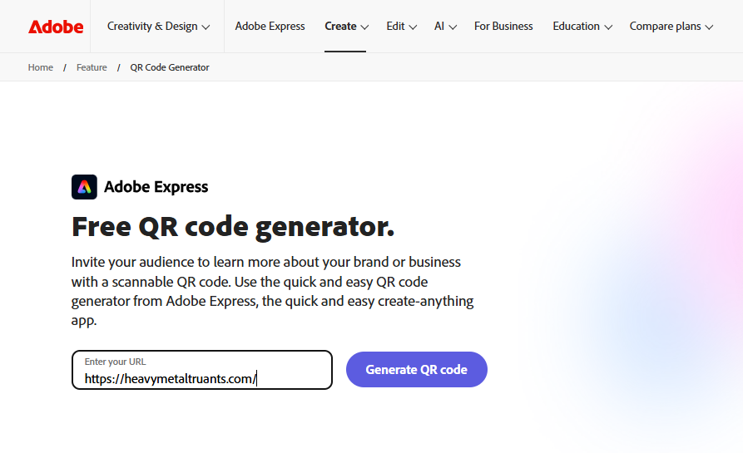
Simply enter in your URL of your sponsorship page and press go.
Download it to your computer and then using the assets in the fund raising pack, add it to the blank space, resize and you’re ready to go.
Here’s one I did for the HMT website…
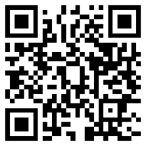

Put the QR code as a screen save on your phone!
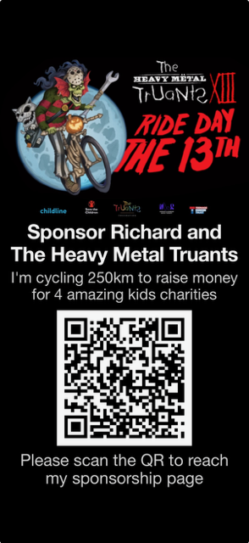

Make a T-shirt to wear on your ride
Using your QR code make a T-short to wear on your training rides – put the QR code on the back and you never know some random may donate!
https://www.spreadshirt.co.uk/personalised/t-shirts

Make a small poster for your bike
If you can use any apps like Canva to produce artwork, then make up a small card, laminate it and attach it to the handlebars of your bike.
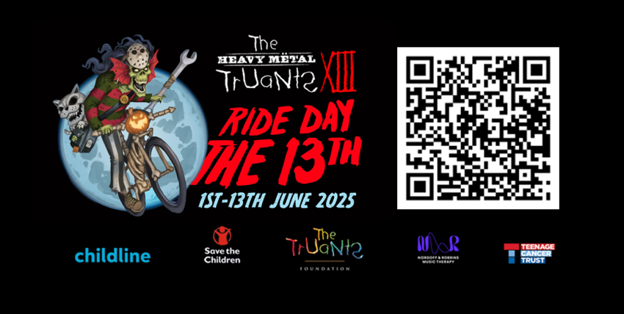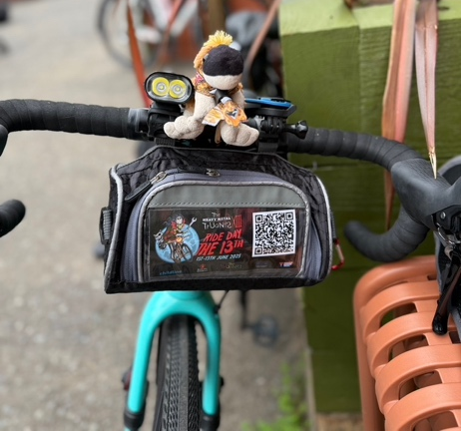

Make some business cards
Ok, this does cost a few quid but is worth it. Moo https://www.moo.com/uk/ can do 50 for £18 and they are quite fun.

Email your work colleagues, contacts, in fact anyone you know…
I’ve found emailing around work has helped but do check with your manager that this is acceptable as not all companies will let you. If you can’t put up posters and I’ll come on to that in a bit.
Here is an example of what I have sent previously which might inspire you.
Hello!
I can’t believe it is that time of the year already when I shake my virtual charity box and badger you yet again (I know I’m sorry) to help me with my charity ride for 4 fantastic children's charities; Nordoff & Robbins Music Therapy, Teenage Cancer Trust, NSPCC Childline, and Save the Children.
This is now my 11th year raising money with the Heavy Metal Truants, cycling 250 kilometres from London to Download Festival. Over this time, we have raised £1.5 million to fund the incredible work these charities do day in day out to help children in their hour of need. I set off two weeks on Wednesday 11th June so fingers crossed for some dry weather as we are camping overnight again – I did not enjoy it last year – it was freezing cold!
I appreciate it’s very cheeky to ask again, but if you can help, that would be truly amazing. You can donate here at Sports Giving.
Many thanks for your continued support.
Cheers, Richard "Iron" Orr
PS For more info on the Truants Foundation and the ride, check out https://heavymetaltruants.com/ plus you can watch the video we made of last year’s ride.

Also remember to send a reminder just before the ride and then another one after to tell everyone how hard it was and that they can still donate!

Make it fun in the office
Each year I put up posters in all of the kitchens. So, using the assets provided make up a poster explaining what you’re doing, why you’re doing, who it helps and why they need to support you! Don’t forget the QR code!
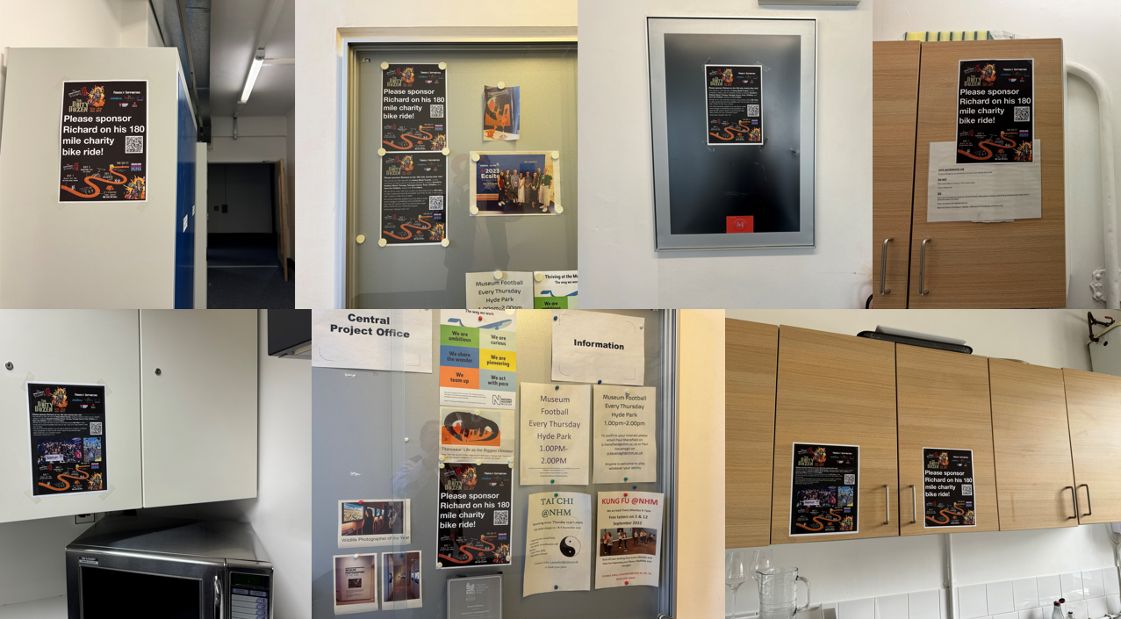
Over the years I’ve done a sweepstake which is free to enter. Make up a poster and place on notice boards / kitchen / lifts / communal areas so folks can see it. You’ll have to provide a prize I just normally buy a 6 pack or some prosecco and maybe give away one of my smelly HMT T-Shirts.
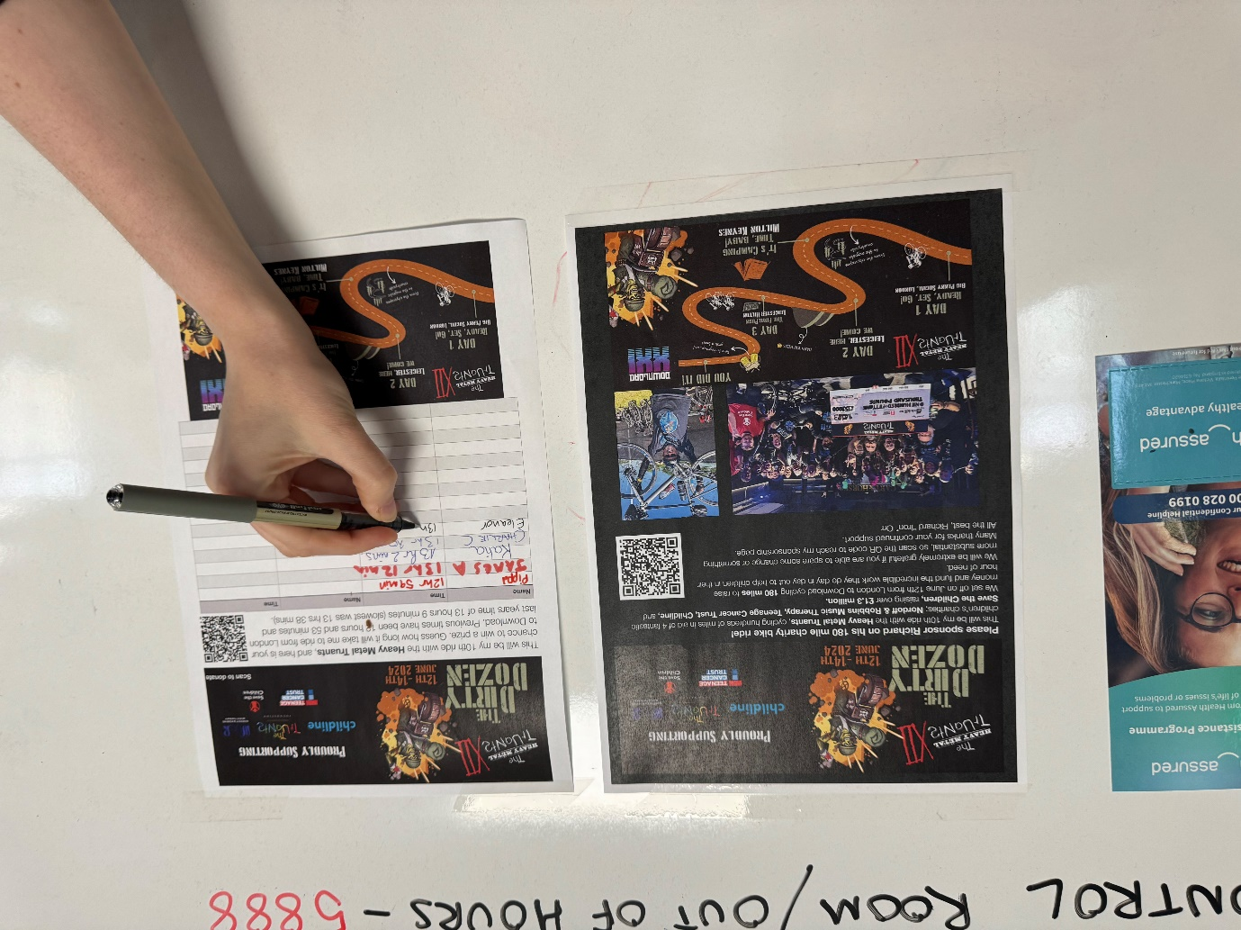

After the ride wear your HMT T-shirt to work every day for a month! Folks will certainly begin to notice and you can keep reminding them to donate.

Put a random slide in your next presentation
On many occasions I’ve hijacked a meeting with a random ”how did that get in there” slide to get more donations.
If you have a Town Hall, All Hands or department meeting this is a great one to add in as an AOB at the end – but again check with your manager – or just do it and say sorry after!
My most successful hijack was adding the slide in at the end of a speech I was doing at a conference, I made over £350 that day!
Again, make sure QR code is on there and big enough for folks to scan with their phones from the back.
If you are no good with PowerPoint or equivalents apps we have created a template for Canva, you can create a free account at https://www.canva.com You will find all of the templates in the fundraising pack.
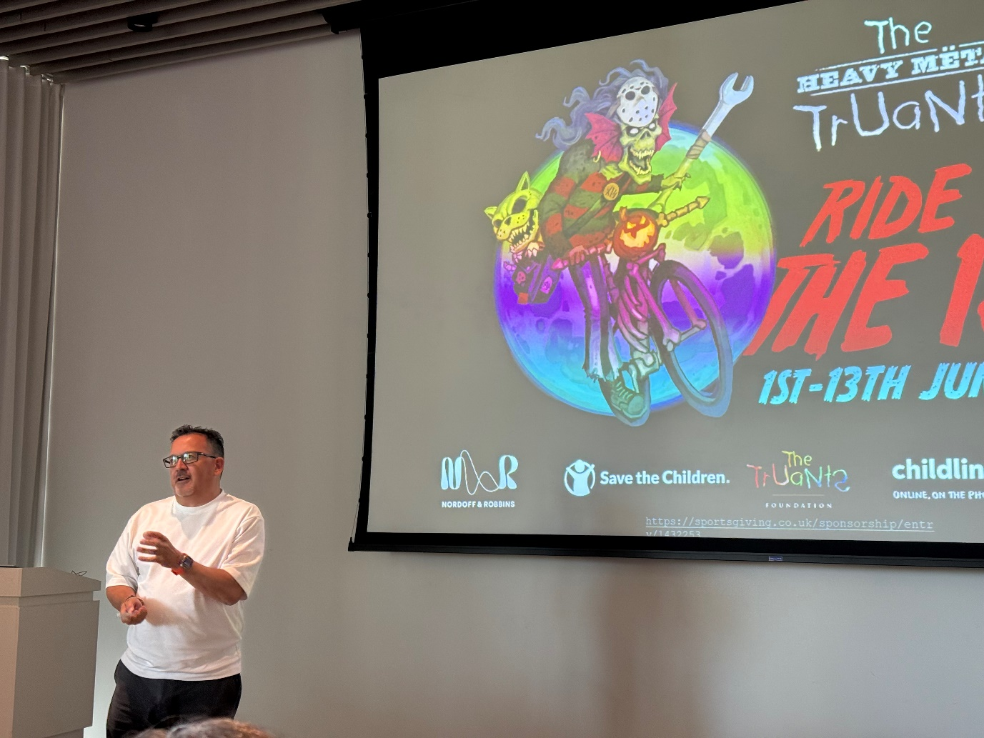

Ask your company for match funding
Many companies do help with charitable donations so enquire with your boss, a director or the HR department to see if they will match fund the money you raise.

Social Media
Using the templates in the assets, update your profile picture and headers across all your favourite social media platforms.
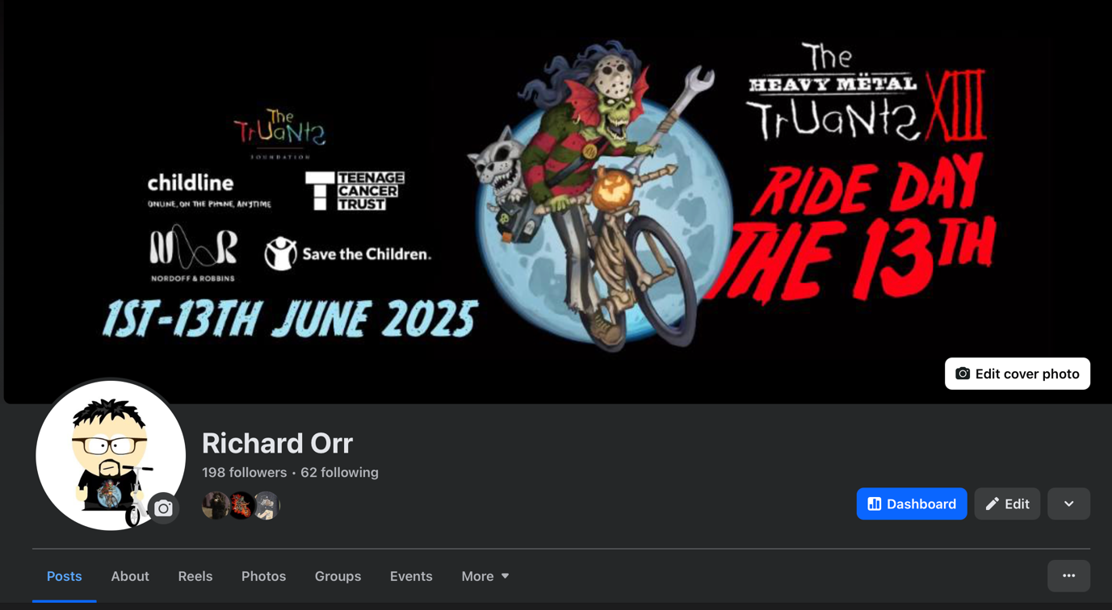
Post regularly and always # the Heavy Metal Truants and all the charities.
When you are on a training ride make sure you record yourself and tell folks what you are doing and why – the sweatier and more knackered you look the better. You can make if fun as there are so many editing tools available to add music and titles.
Share the videos from the charities saying how the donations will help them. These are really powerful.
On your birthday – make a post saying “don’t buy me a pint or send me a card – make a donation!”
Use your creativity to make think folks think about what they are spending money on. At lunchtime tell your friends to take a sandwich to work instead of buying a Pret sandwich and send you the money – it far healthier. Or on Friday evening send a note saying “Hey don’t buy that one-for-the-road pint” and get them to send you the cash instead!

Message your friends
Use WhatsApp to message your friends with a link to your sponsorship page, make a video and send that. Don’t be embarrassed just guilt your friends into donating and tell no matter how small – remind them even £5 will help the NSPCC Childline to answer a call to a vulnerable child.

Tell everyone what their donation actually does!
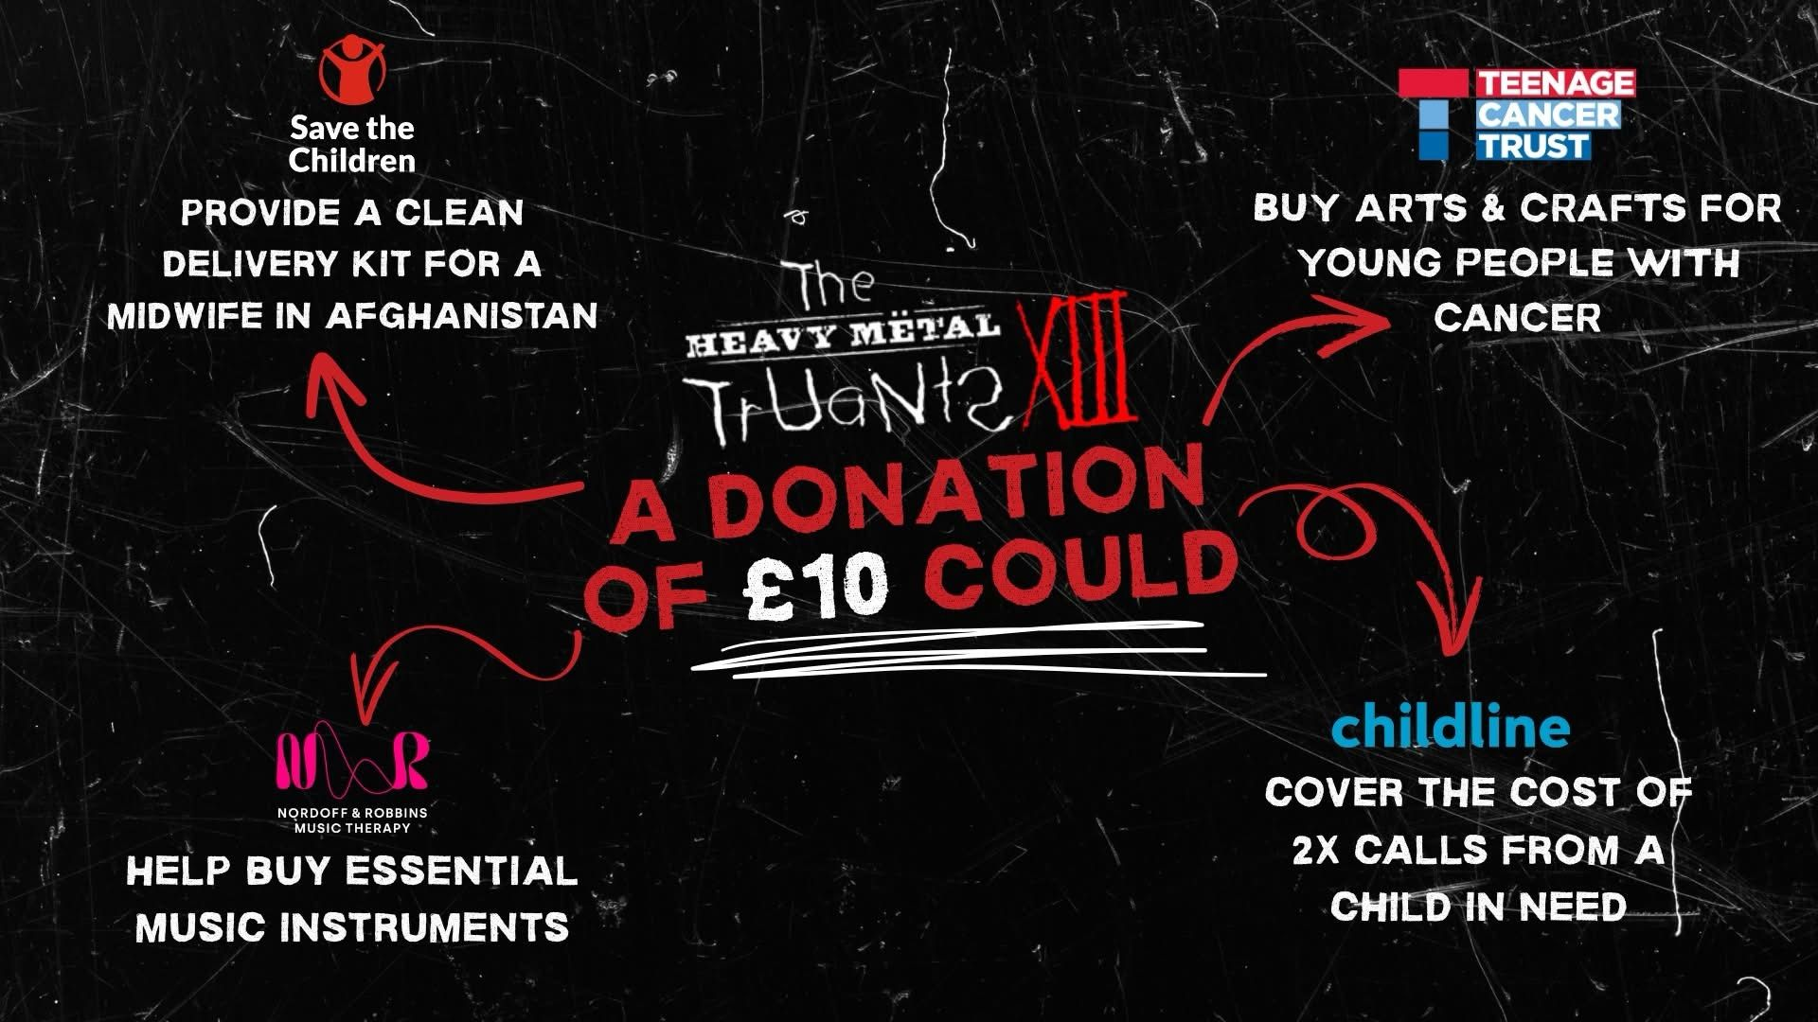

- £10 pays for two calls to ChildLine
- £80 allows a Nordoff & Robbins session
- £25 gives an hour of support from a Youth Support Coordinator (helping with studies, relationships, mental well-being)
- £60 delivers two hours of expert care from a specialist nurse, addressing medical and emotional needs
- £200 funds confidence-boosting workshops (wigs, makeup, clothes) for body image.
- £1,000 can equip a unit with essential comforts like sofas, TVs, pool tables to feel like home

Important! Tell folks to claim gift aid!
If your donor is a UK taxpayer, they can claim Gift Aid. This is incredibly important as it can add 25p for every £1 donated through Gift Aid.

