How to Film Like a Heavy Metal Truant
(and Raise More While You’re At It)

Why Updates Matter
Heavy Metal Truants has never been about quietly suffering in the background.
The rides that raise the most money - year after year - are not always the longest, fastest or most brutal. They are the ones people see. The ones people can follow. The ones that bring supporters along for the journey.
Fundraising is not a single ask at the end. It is a story told over time.
When you post updates - from the road, the gym, or your kitchen at home - you are doing three critical things:
- You remind people why you signed up
- You show the effort behind the ask
- You give supporters permission to care, share, and donate
Most people want to help. They just need reminding - and they need to feel connected to what you’re doing.

Visibility = Accountability = Donations
Think of your updates like training miles.
One big ride with no updates is impressive - but easy to forget.
Regular check-ins build momentum, familiarity and trust.
When people see:
- You showing up tired
- You pushing through doubt
- You committing publicly
They are far more likely to:
- Donate again
- Increase their donation
- Share your link
- Cheer you on (which matters more than you think)
This Isn’t About Being “Good on Camera”
You don’t need to be polished.
You don’t need perfect lighting, editing or confidence.
In fact, rough edges work in your favour.
Sweaty, breathless, honest updates outperform scripted ones every time. A 30-second phone video filmed on the side of the road will often raise more than a carefully written post typed at home.
Why?
Because it feels real.
Because it shows effort.
Because it reminds people this is hard - and worth supporting.
Your Ride Is Personal - Let People In
Every rider has a reason for being here:
- A charity close to their heart
- A personal challenge
- A need to prove something to themselves
- Or simply a refusal to do things the easy way
Updates are how you share that reason without having to explain it all at once.
You don’t need to overshare.
You just need to show up.

We’re here to help!
The sections that follow are designed to:
- Make filming easy and repeatable
- Remove the awkwardness from asking for money
- Give you practical ideas that actually work
- Help new and returning riders raise more, with less stress
Use what fits you. Ignore what doesn’t. But post something.
Because every update is another reminder that this ride matters - and that you’re doing something extraordinary for kids who need it.

1. How to Set Up Your Camera

(So People Actually Watch — and Donate)
You don’t need fancy kit. You do need to be seen, heard, and believable. The goal isn’t perfection - it’s authenticity, consistency, and momentum.
Think of this like training: small improvements, done often is the best way to reap the benefits.

A. Filming on the Road (Ride Updates)
Best setup
- Smartphone or action cam
- Stop safely if phone needs to be held
Helmet off if you’re not moving - faces raise more money than helmets.
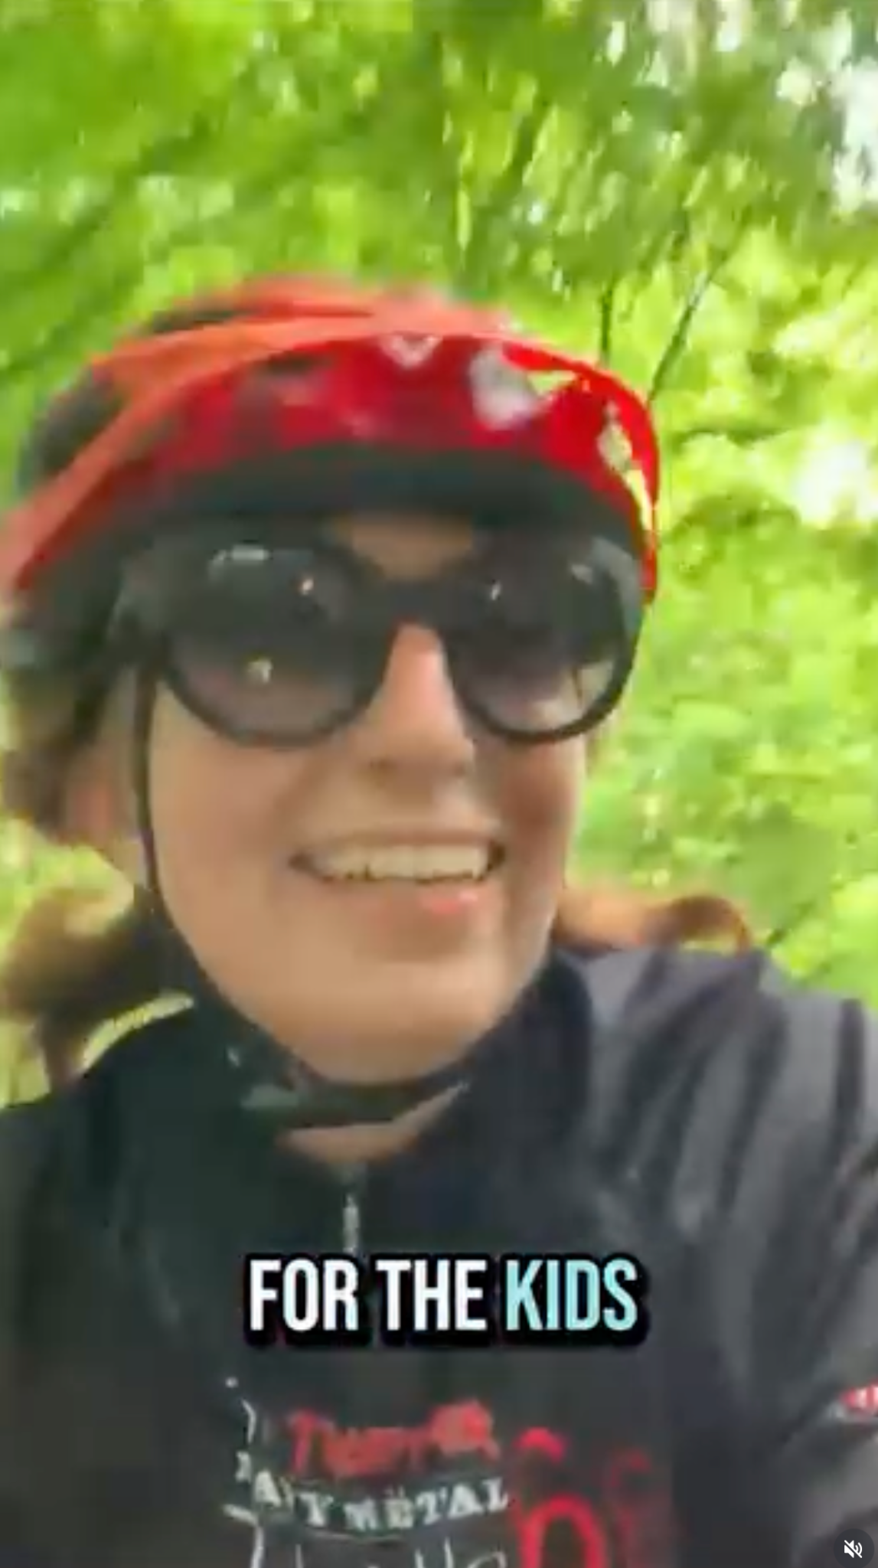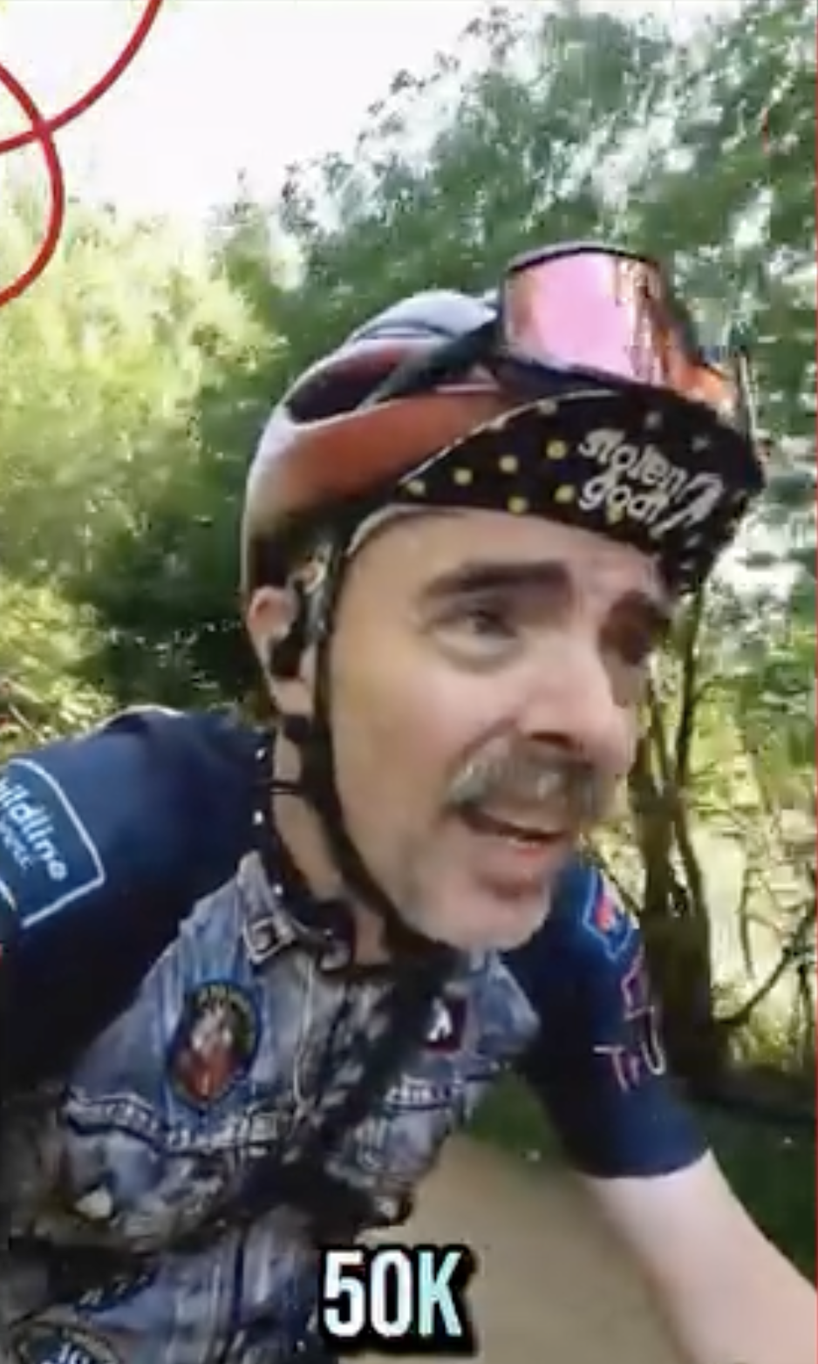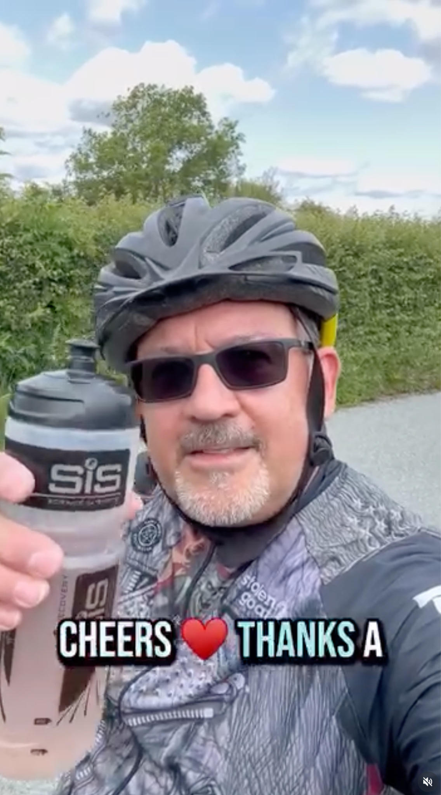
Camera position
- Hold the phone at eye level or slightly above
- Arm’s length - not right in your face
- Landscape for YouTube / Facebook
- Portrait for Instagram, TikTok, Shorts
Framing
- Your face = centre frame
- Bike visible somewhere in shot (signals effort instantly)
- Horizon straight (unless you’re actively falling off, in which case… fair)
Audio
- Turn away from traffic and wind
- Speak clearly but show your emotion
What to say (30–45 seconds)
- Where you are
- How far you’ve ridden
- How it feels (honest beats heroic)
- Who you’re riding for
- A clear ask: “If you can spare £5…”
Think: mid-ride check-in, not a documentary.

B. Filming at the Gym or Training Indoors
Best setup
Best setup
- Phone propped on a bottle, bench, or mini tripod
- Selfie camera is fine - eye contact matters more than resolution
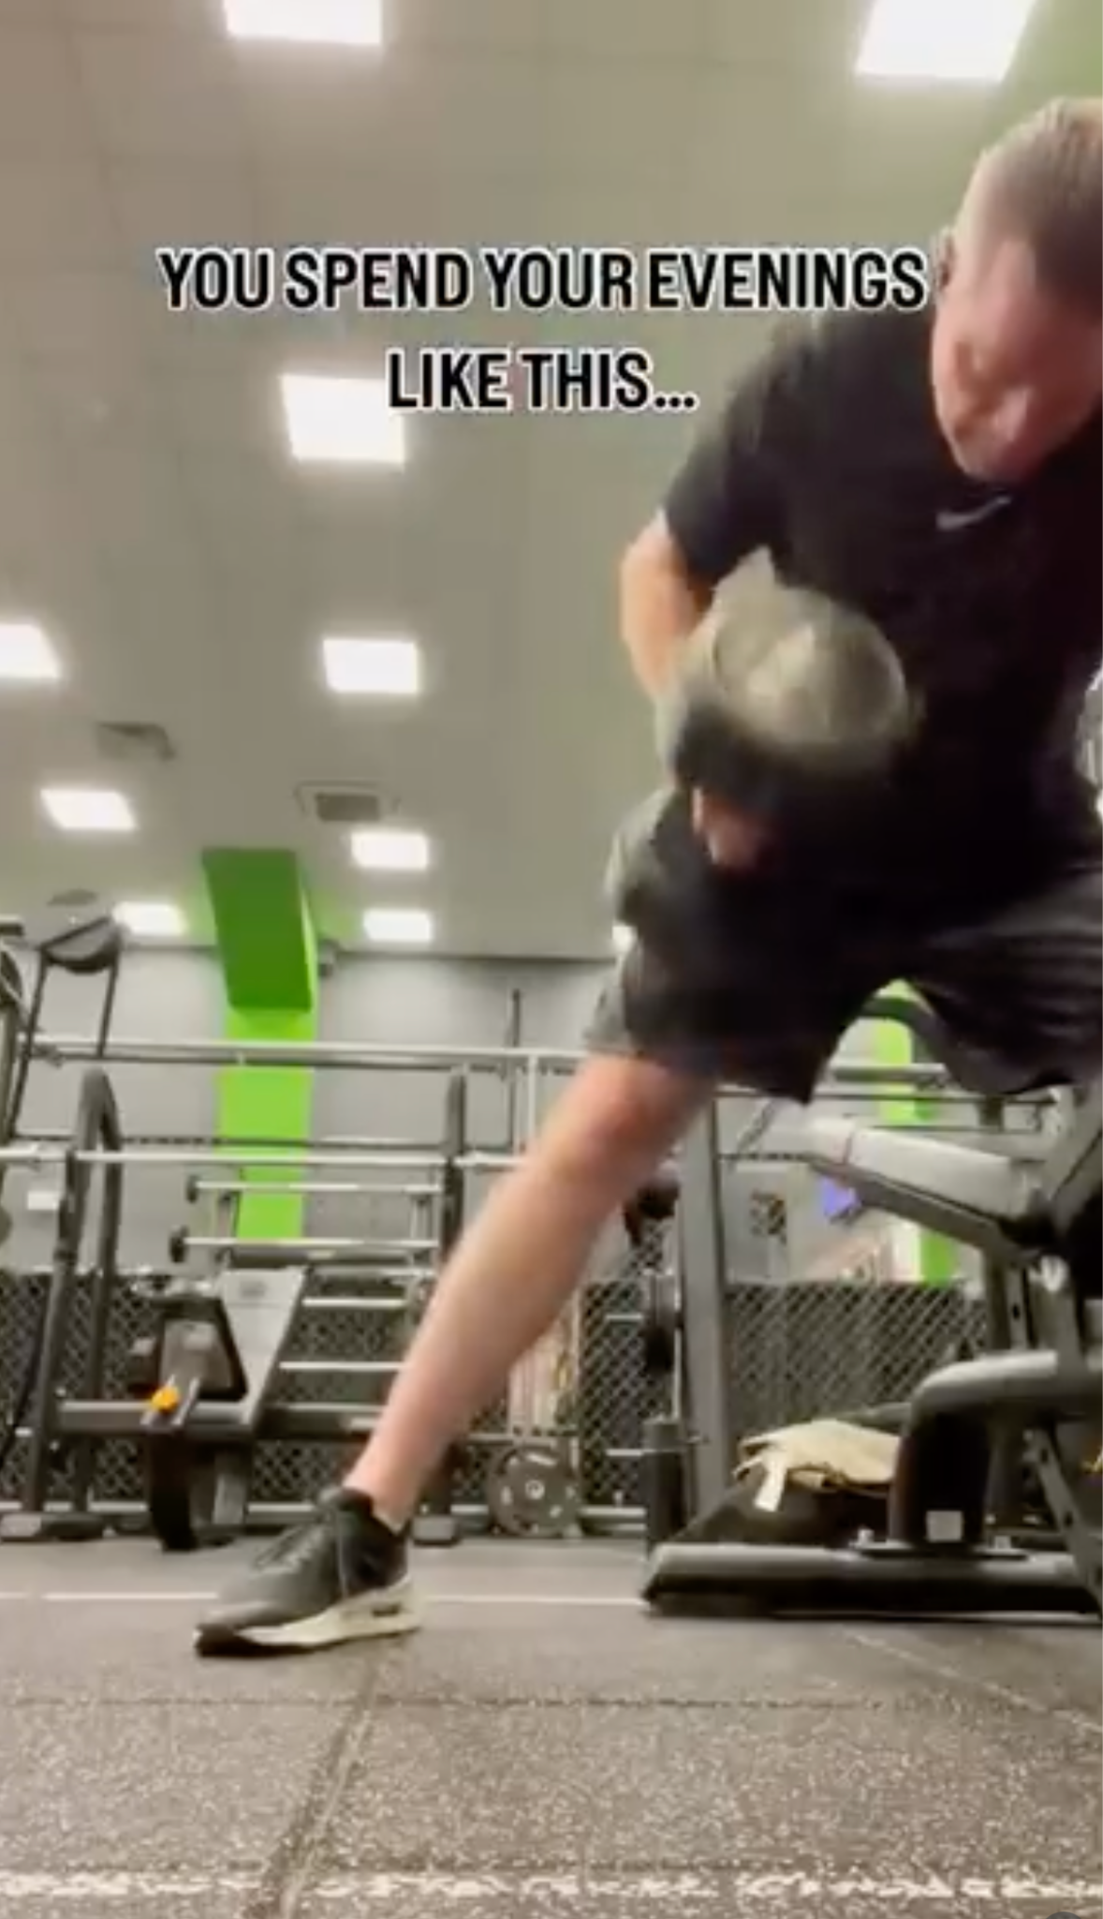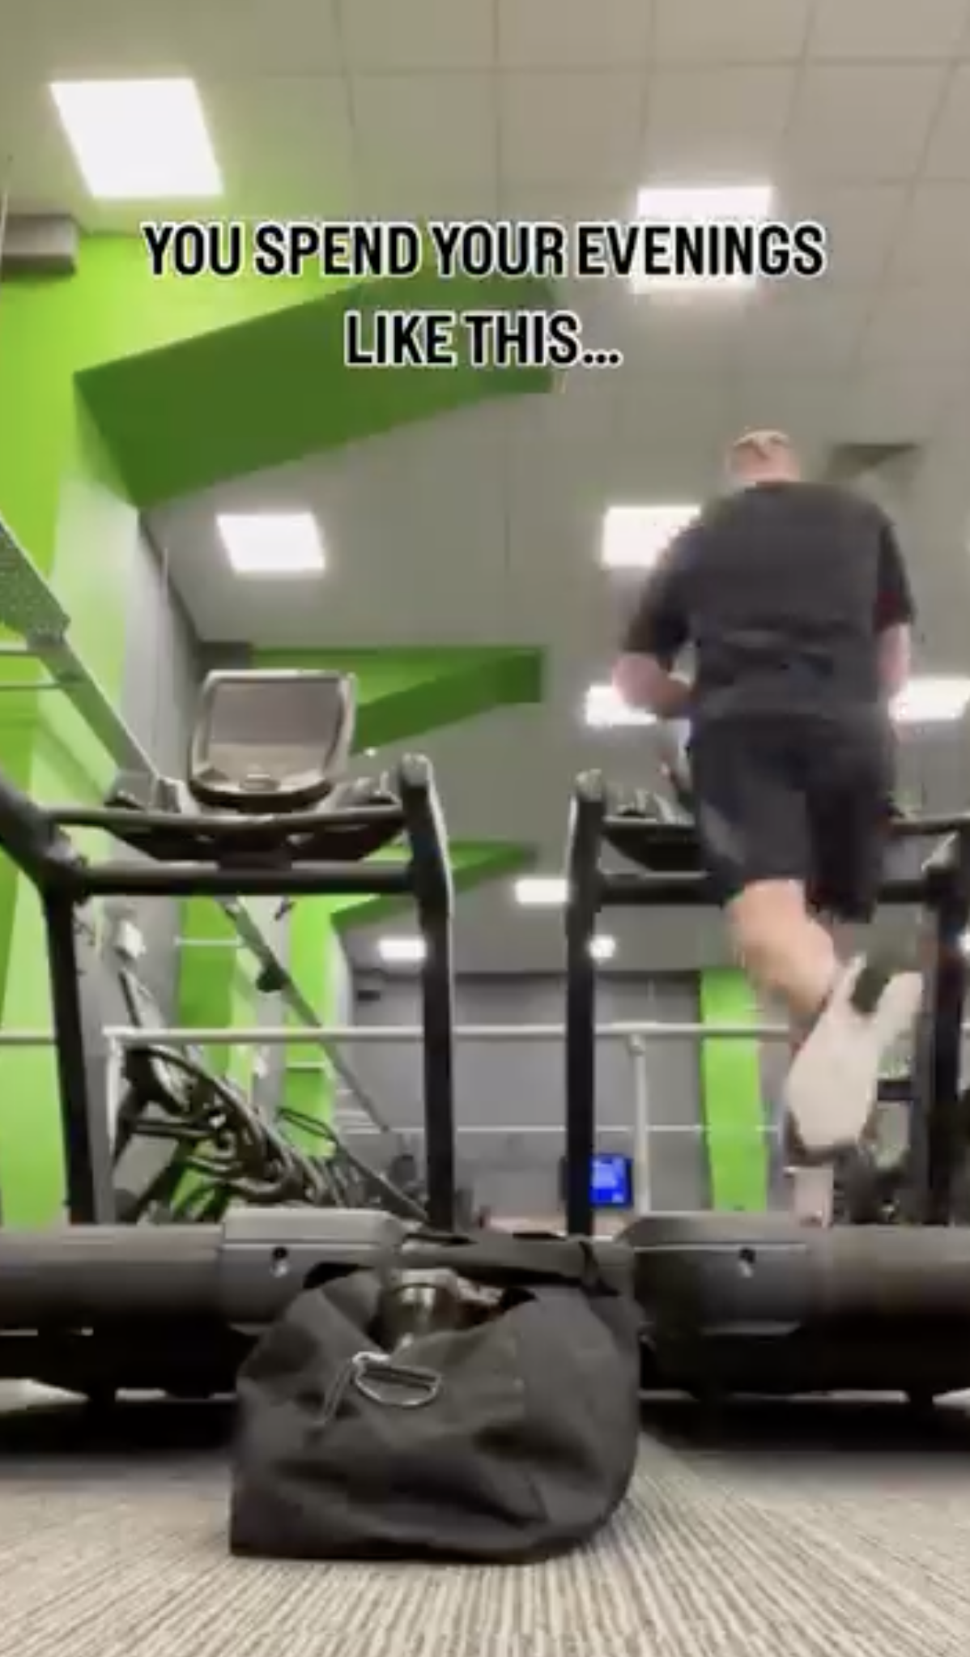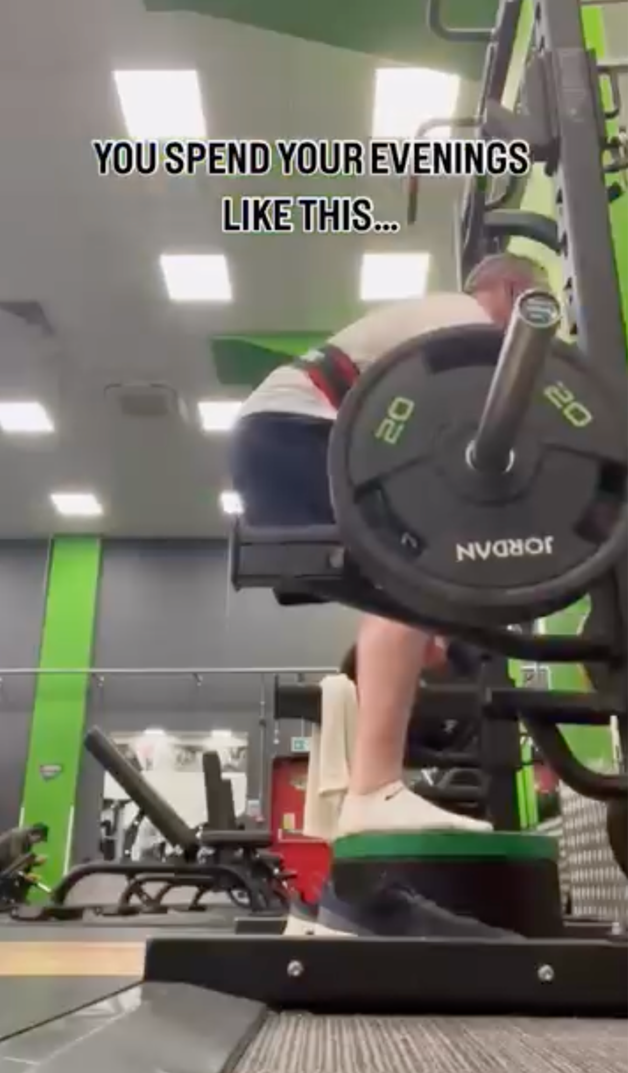
Lighting
- Face the light (window or overhead lights in front of you)
- Avoid strong lights directly behind your head
Background
- Bike, treadmill, weights - visual proof of effort
- Messy is fine; mysterious less so
Timing
- Film mid-session or immediately after
- Sweat sells commitment (sorry)
What to say
- “This is session X of training for HMTXIV”
- One sentence on why you’re doing it
- One clear fundraising push
If you’re gasping slightly, good. People believe that.
C. Filming From Home (Fundraising Updates)

Best setup
- Phone stacked on books or shelf at eye height
- Sit or stand still - no pacing like a hostage video
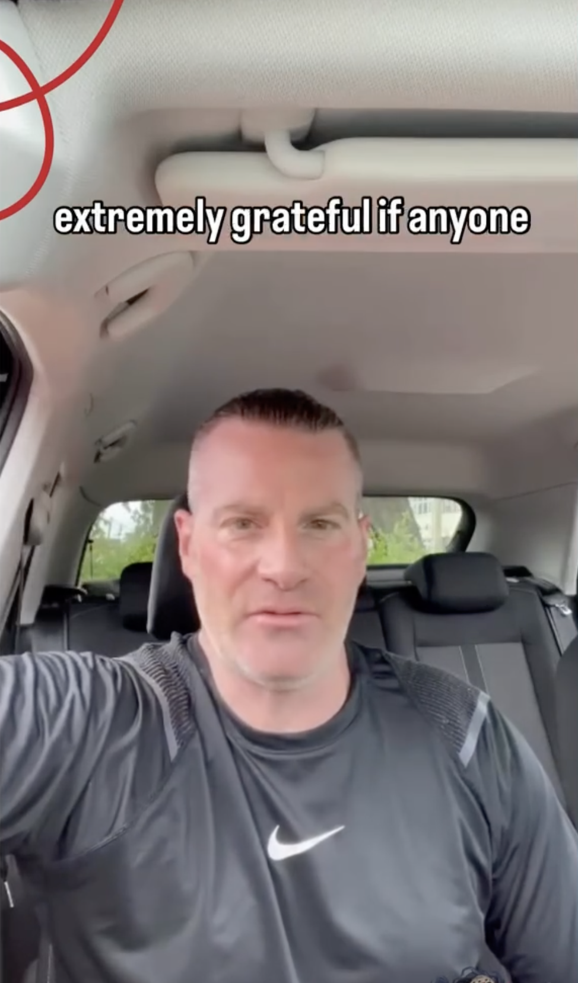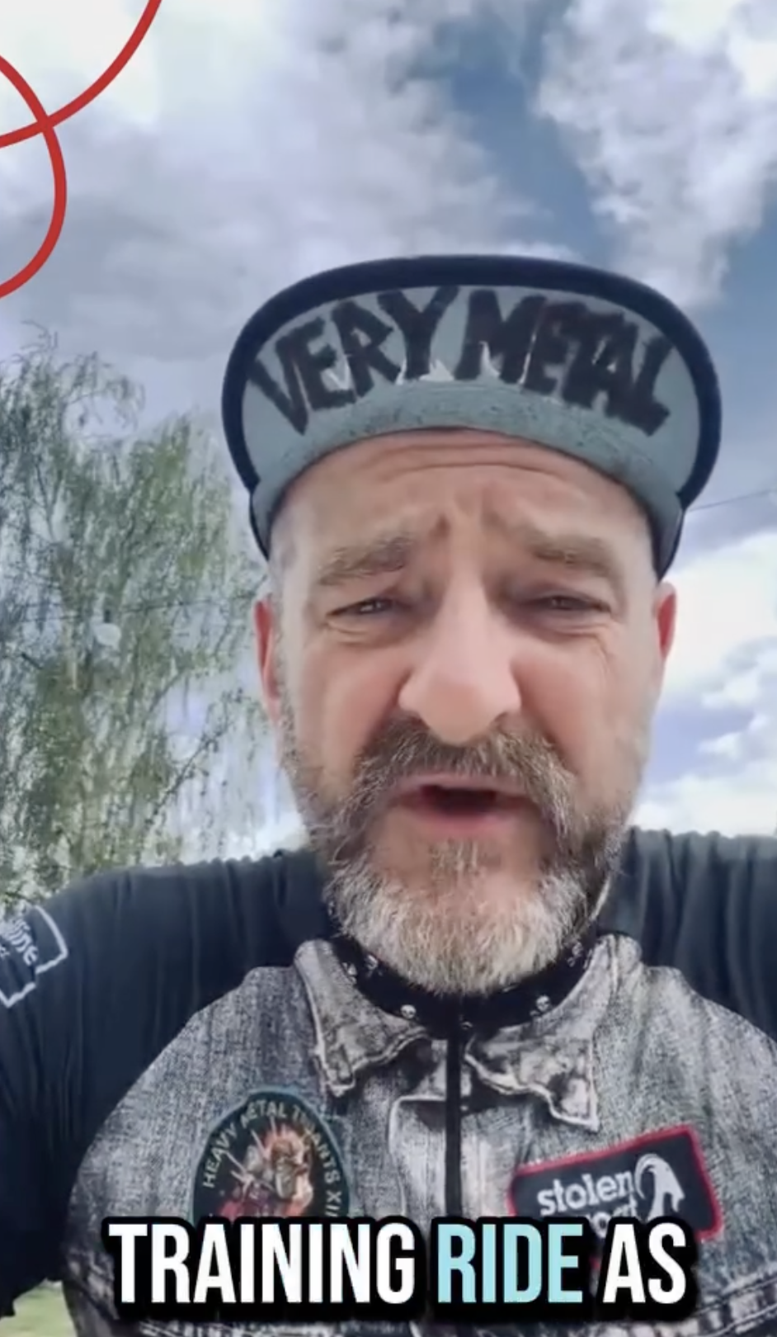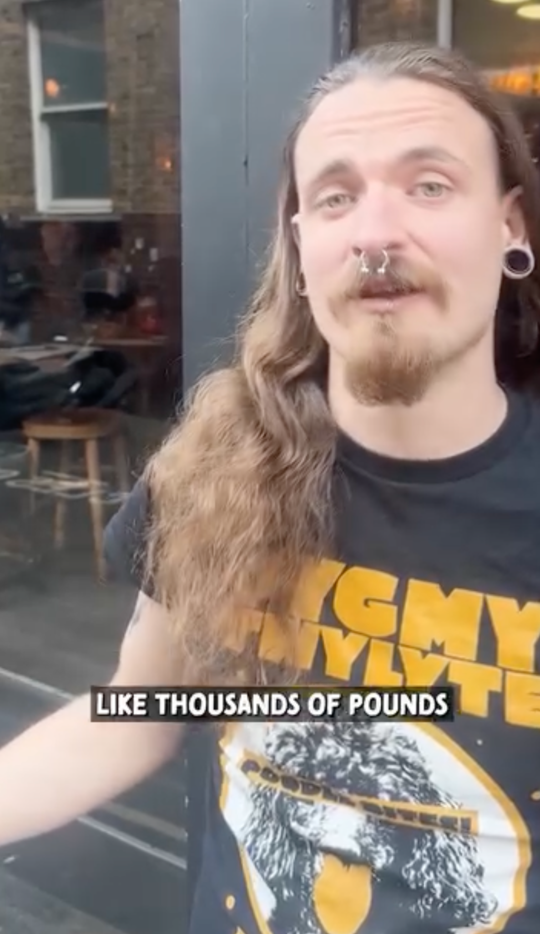
Lighting
- Window in front of you, not behind
- Evening? Lamps on, main light off if possible
Audio
- Quiet room
- Phone mic is fine - just don’t shout at it

What works best here
- Thank-yous
- Milestones
- Honest reflections
- “I wasn’t sure I could do this, but…”
These videos convert well. Use them.

2. Content That Raises Money (Not Just Likes)
Every post should do one of three things:
- Show effort
- Show vulnerability
- Ask clearly for support

Proven Fundraising Video Prompts
- “I didn’t want to get on the bike today, but…”
- “This ride scares me because…”
- “I’m £___ away from my target - can you help?”
- “This one’s for the kids who don’t get a choice.”
Short. Direct. Human.

3. The Golden Rule
People don’t donate because you’re cycling.
They donate because:
- You showed up
- You were honest
- You asked them directly
Film often. Keep it rough. Keep it real. Keep asking.
Go and check out our Fundraising Ideas document for more!

